Maxine,

I routinely see breast cancer patients post-surgically and post-radiation.  Early intervention is better, but they can be treated any time after treatment.  As you know, survivorship comes with all sorts of challenges from the initial treatment regimen.  You can certainly treat symptomatic trigger points in the shoulder girdle region.  In addition, micro-needling around scars and radiation burns can down regulate the inflammatory responses (particularity the chronic inflammatory responses) that create hypertrophic scarring and contractures.  One big challenge is getting the physicians to understand the underlying physiology of dry needling interventions.  Also, being very cognizant of safety rules around dry needling the muscles of the chest wall and implants.  There is some complicated biochemistry and immunology involved, but basically dry needling is very helpful in these situations with physician support and clearance.  Happy to speak to you by zoom.  Best wishes,  Mark Hernandez, PT

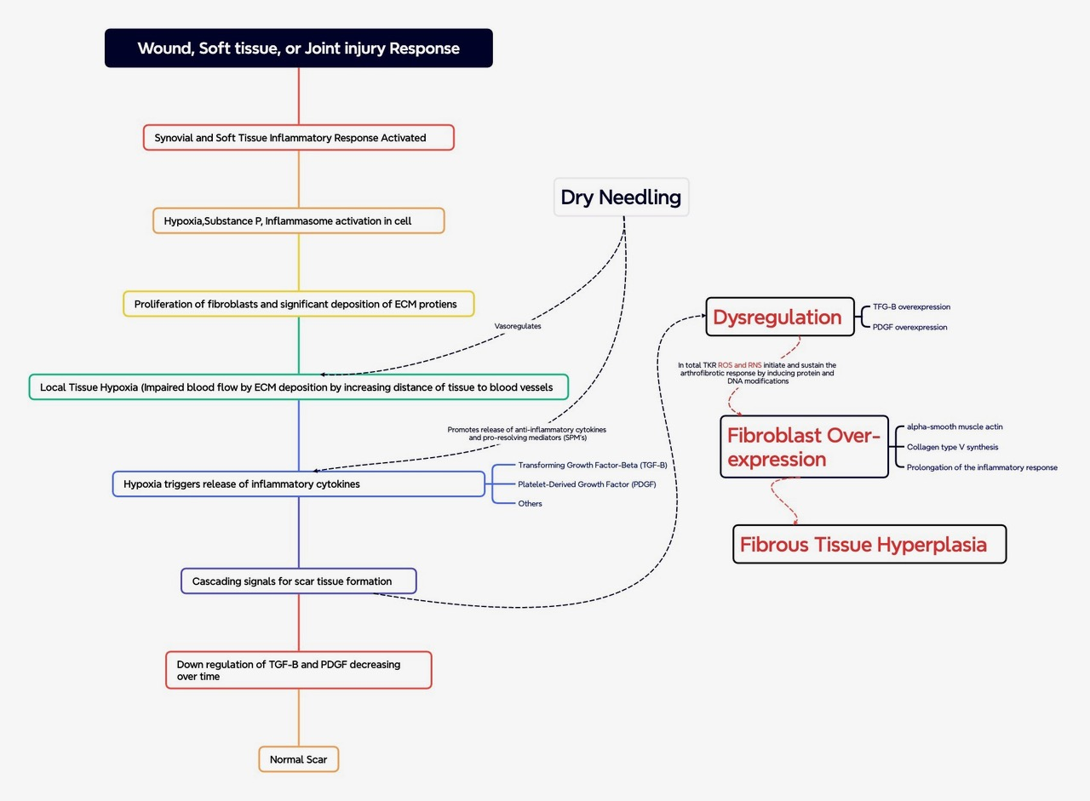

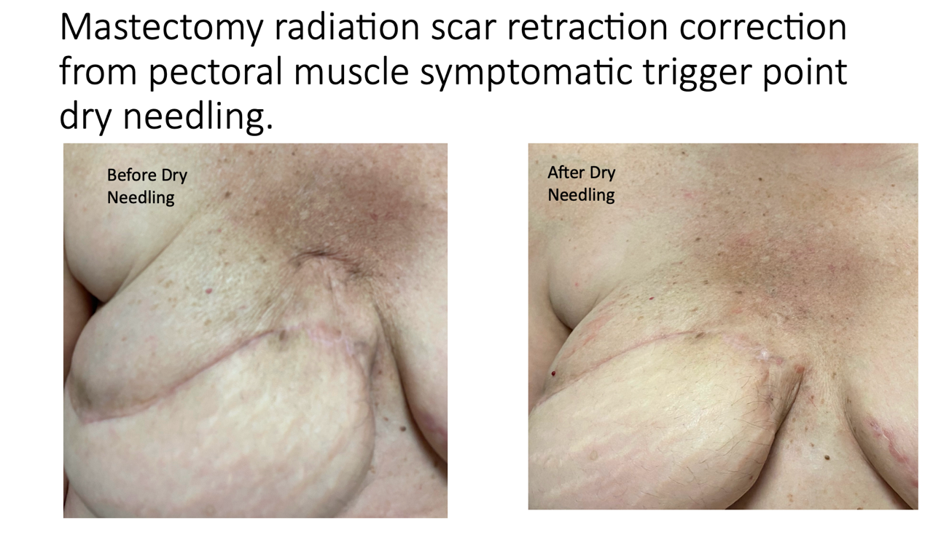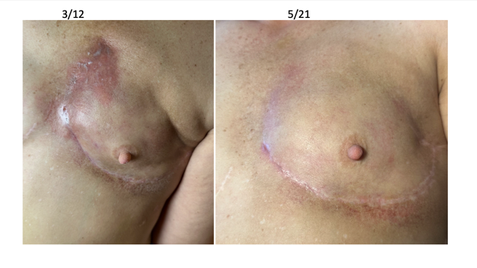Implance removal scar.pdf